Archbishop Harry J. Flynn Catechetical Institute
Module 3 Lesson 5 CCC 2030-2141
Instructor: Deacon Dan Gannon

The Church: The Decalogue and the 1st Commandment

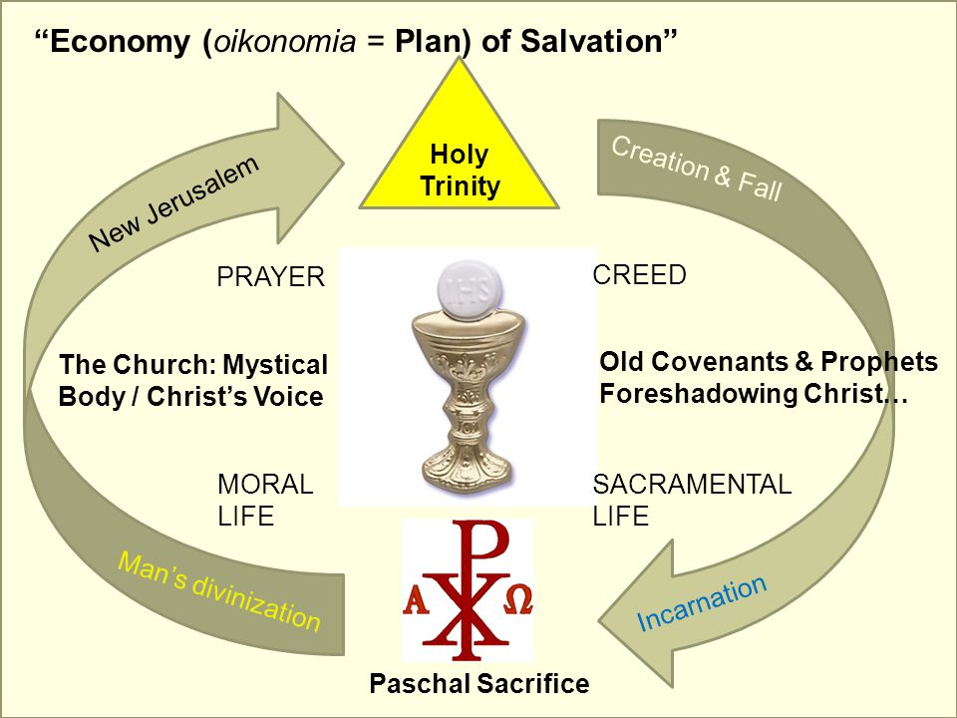

Decalogue – In Perspective

- Always in Context of Christ’s law; Not “rules” but a covenant of love
- Christ’s new law of love “fulfills, refines, surpasses and leads the old law to its perfection; releases their hidden potential; reform of the heart”
- Christ’s law of love is a precept… a commandment
- Christian morality finds it’s origin in the question of happiness (beatitude) set out in the Beatitudes/Sermon on the Mount
  - … NOT in negative moral precepts

- According to St. Thomas Aquinas, the old law was incomplete/imperfect, because it ordered people to God, but did not instill within them the power to reach God.
Matthew 5:17 Do not think that I have come to abolish the law or the prophets. I have come not to abolish but to fulfill.

John 13:34 I give you a new commandment:* love one another. As I have loved you, so you also should love one another.

- St. Paul preached not obligations… but freedom from the old law through Christ’s perfect sacrifice & fulfillment unto the new law of love

- Mosaic Law – St. Thomas held mosaic law structured life of Israel in 3 ways
  - Moral
  - Ceremonial
  - Judicial precepts
- Christ’s Paschal Mystery fulfills Mosaic law on the Cross
  - Priest
  - Prophet
  - King

- New Law: Christian morality and actions have their origin and teleology in happiness, the good and the beautiful
  - Jesus didn’t liberalize the Old Law, he tightened it

The Church, Mother and Teacher

- Not a ‘legalist’ but a ‘lover’, protector of the “covenant love”

CCC 2030 It is in the Church, in communion with all the baptized, that the Christian fulfills his vocation. From the Church he receives the Word of God containing the teachings of "the law of Christ." From the Church he receives the grace of the sacraments that sustains him on the "way." From the Church he learns the example of holiness and recognizes its model and source in the all-holy Virgin Mary; he discerns it in the authentic witness of those who live it; he discovers it in the spiritual tradition and long history of the saints who have gone before him and whom the liturgy celebrates in the rhythms of the sanctoral cycle

CCC 2034 The Roman Pontiff and the bishops are "authentic teachers, that is, teachers endowed with the authority of Christ, who preach the faith to the people entrusted to them, the faith to be believed and put into practice." The ordinary and universal Magisterium of the Pope and the bishops in communion with him teach the faithful the truth to believe, the charity to practice, the beatitude to hope for

- Church is our source of grace, nourishment, and healing—Eucharist, Reconciliation
- Scripture + Tradition interpreted by Magisterium
- Conscience—not subjective; must be formed via Magisterium
  - Purpose of Magisterium is salvation of souls

CCC 2040 Thus a true filial spirit toward the Church can develop among Christians. It is the normal flowering of the baptismal grace which has begotten us in the womb of the Church and made us members of the Body of Christ. In her motherly care, the Church grants us the mercy of God which prevails over all our sins and is especially at work in the sacrament of reconciliation. With a mother's foresight, she also lavishes on us day after day in her liturgy the nourishment of the Word and Eucharist of the Lord.

- Precepts of the Church – “very necessary minimum” (2042) for growth in love of God and neighbor
  - Mass – Sunday & Holy Days
  - Reconciliation – yearly
  - Eucharist received – yearly (in Easter season)
  - Fasting & Abstinence observed as required
  - Contribute to material support of the Church
- Must avoid pharisaical approach to the Five Precepts of the Church!
- Liturgical observances lead to rectified and good life “Operatio sequitur esse”
- Church is therefore missionary by nature

Decalogue – Love of God & Neighbor

- First tablet: 3 commandments = love of God
- Second tablet: 7 commandments = love of neighbor

- Commandments come in “second place” because they express the implication of belonging to God via covenant

CCC 2062 The Commandments properly so-called come in the second place: they express the implications of belonging to God through the establishment of the covenant. Moral existence is a response to the Lord's loving initiative. It is the acknowledgement and homage given to God and a worship of thanksgiving. It is cooperation with the plan God pursues in history.

CCC 2060 The gift of the commandments and of the Law is part of the covenant God sealed with his own. In Exodus, the revelation of the "ten words" is granted between the proposal of the covenant22 and its conclusion - after the people had committed themselves to "do" all that the Lord had said, and to "obey" it.23 The Decalogue is never handed on without first recalling the covenant ("The LORD our God made a covenant with us in Horeb.").

CCC 2056 The word "Decalogue" means literally "ten words."11 God revealed these "ten words" to his people on the holy mountain. They were written "with the finger of God,"12 unlike the other commandments written by Moses.13 They are pre-eminently the words of God. They are handed on to us in the books of Exodus14 and Deuteronomy.15 Beginning with the Old Testament, the sacred books refer to the "ten words,"16 but it is in the New Covenant in Jesus Christ that their full meaning will be revealed.

CCC 2086 "The first commandment embraces faith, hope, and charity. When we say 'God' we confess a constant, unchangeable being, always the same, faithful and just, without any evil. It follows that we must necessarily accept his words and have complete faith in him and acknowledge his authority. He is almighty, merciful, and infinitely beneficent. Who could not place all hope in him? Who could not love him when contemplating the treasures of goodness and love he has poured out on us? Hence the formula God employs in the Scripture at the beginning and end of his commandments: 'I am the LORD.'"

- Theological Virtues
  - Faith
  - Hope
  - Charity

CCC 2087 Our moral life has its source in faith in God who reveals his love to us. St. Paul speaks of the "obedience of faith"9 as our first obligation. He shows that "ignorance of God" is the principle and explanation of all moral deviations.10 Our duty toward God is to believe in him and to bear witness to him.

CCC 2090 When God reveals Himself and calls him, man cannot fully respond to the divine love by his own powers. He must hope that God will give him the capacity to love Him in return and to act in conformity with the commandments of charity. Hope is the confident expectation of divine blessing and the beatific vision of God; it is also the fear of offending God's love and of incurring punishment.

CCC 2093 Faith in God's love encompasses the call and the obligation to respond with sincere love to divine charity. The first commandment enjoins us to love God above everything and all creatures for him and because of him.

